# AEM TASK – 9

**Newsroom Portfolio**

## Header Configuration

* Used the **OOTB header component**.
* Created the following menu items in the header:
  + **Home**
  + **News**
  + **About Me**
  + **Contact Me**
* Styled the header appropriately to maintain a professional look.
* Implemented various news pages that displays the latest articles.

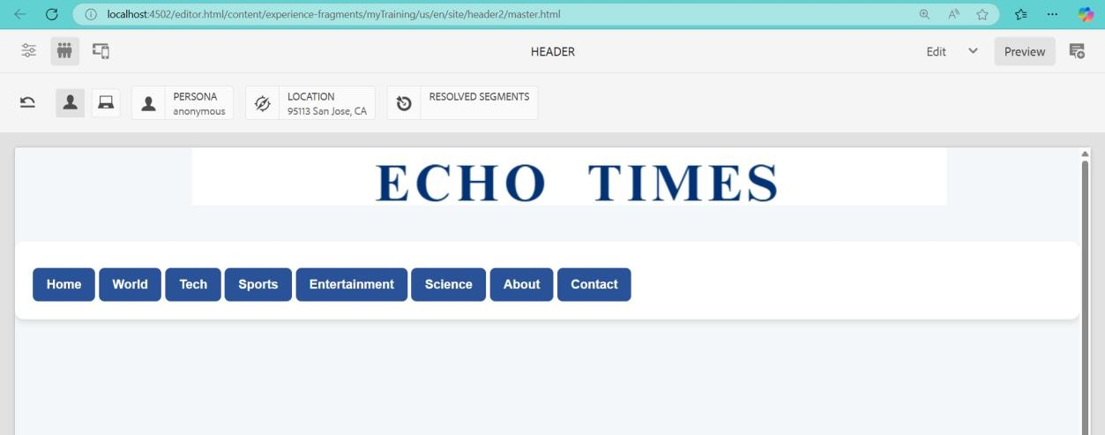

## Footer Configuration

* The footer includes:
  + **About Me Section**
  + **Contact Me Section**
  + **Social Media Links**
* Ensured footer consistency across all pages by including it at the template level.

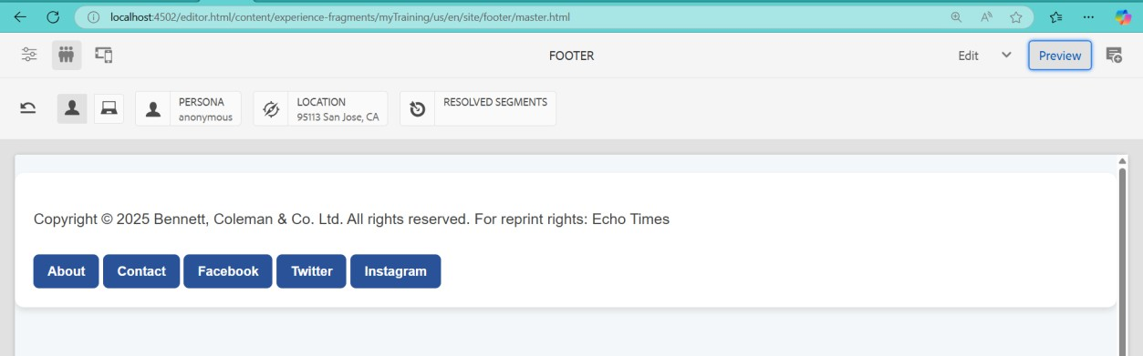

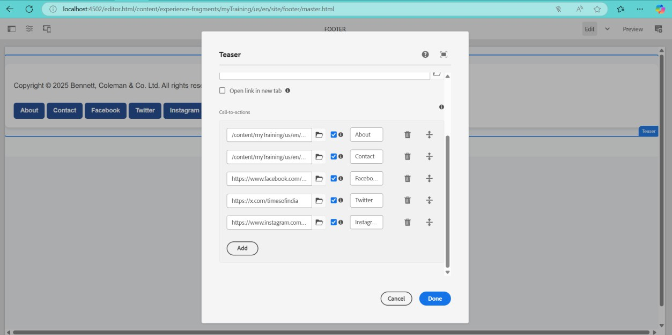

## Homepage Implementation

* Used the **OOTB Teaser Component**.
* Displayed an award ceremony section for journalists with:
  + **Image**
  + **Title**
  + **Description**
  + **CTA (Call to Action)** linking to a dedicated award page.

# Home Page



## Newsroom Component Development

* Created a **Newsroom Component** to fetch and display news dynamically.
* The component retrieves all news articles under /content/news.
* Each news article is displayed as a **card** containing:
  + **Title**
  + **Image**
  + **News Details**
  + **Unique Content for Each Card**

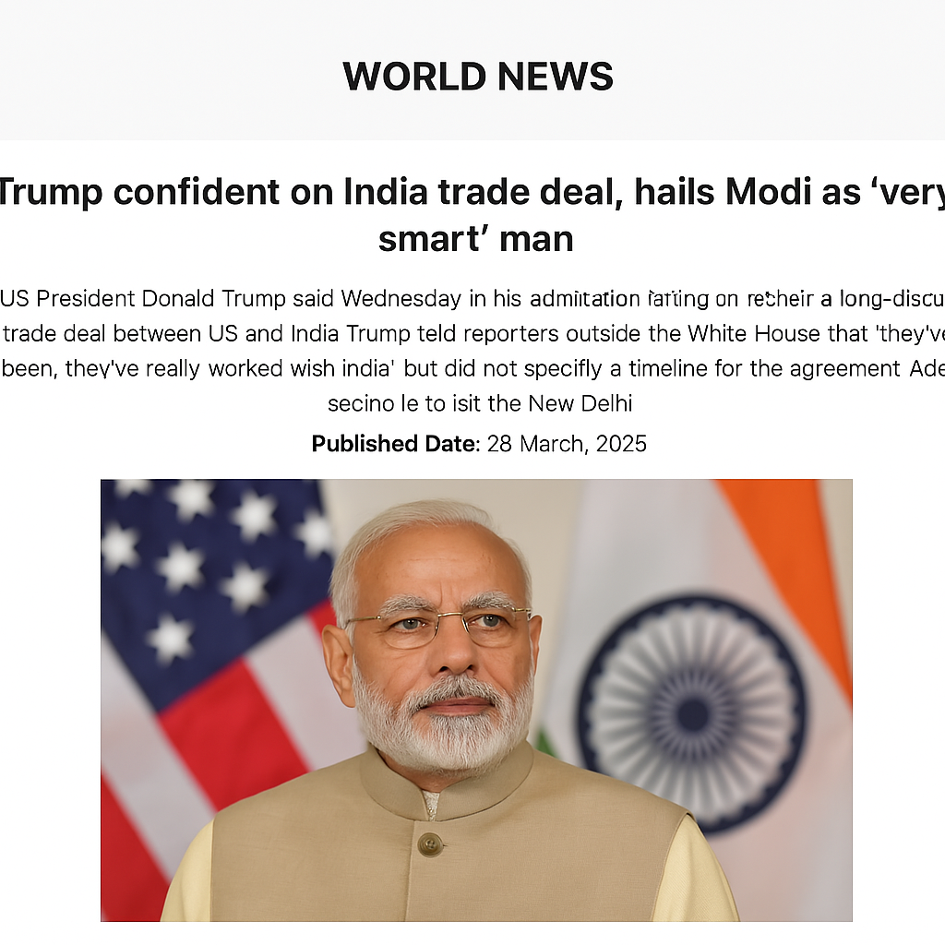

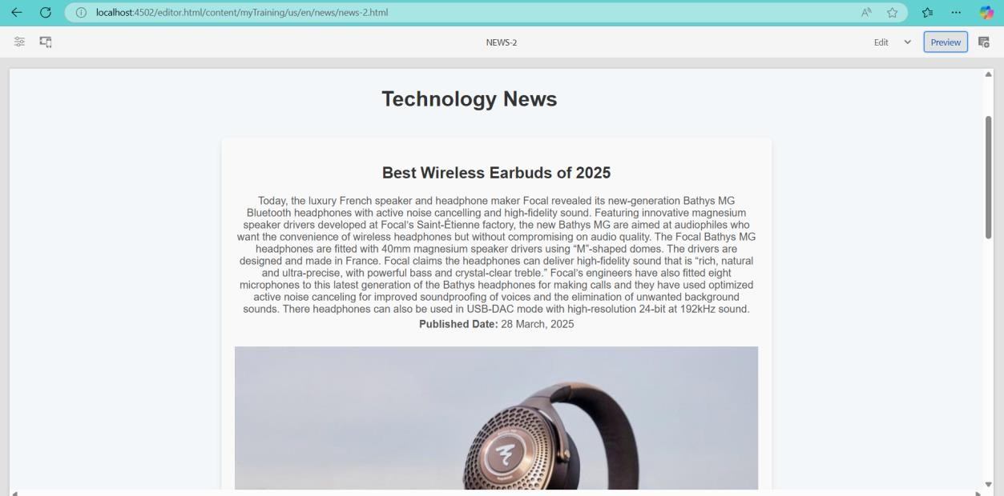

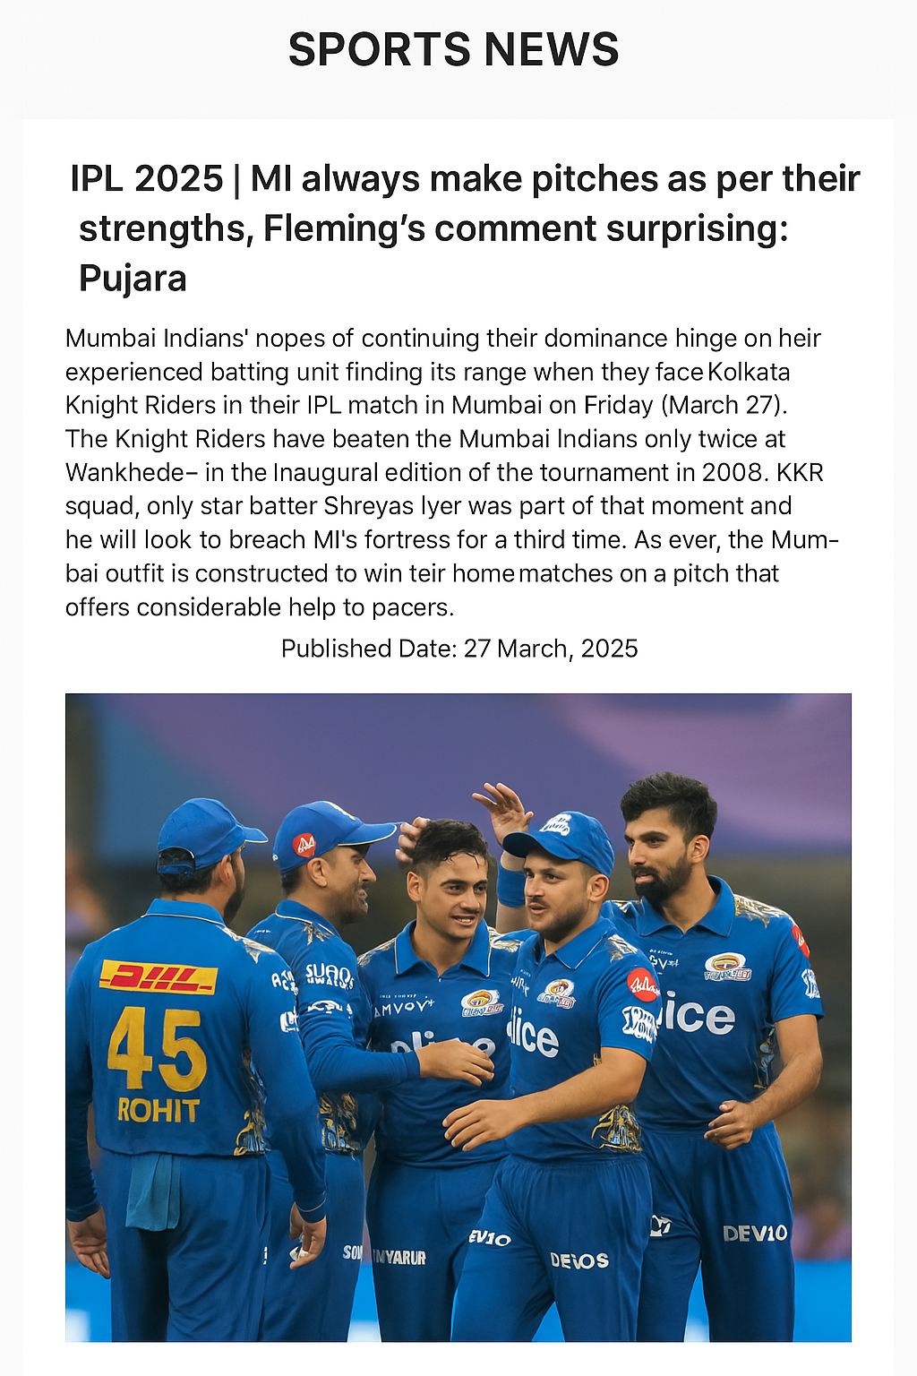

## News Article Pages

* Created news article pages under the /content/news hierarchy.
* Each page is authored with:
  + **Title**
  + **Image**
  + **Text Component** (for article content)
* Ensured the Newsroom component fetches data dynamically from these authored pages.

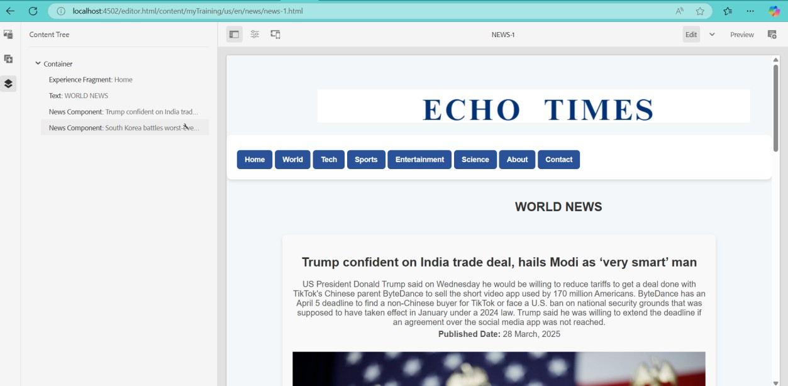

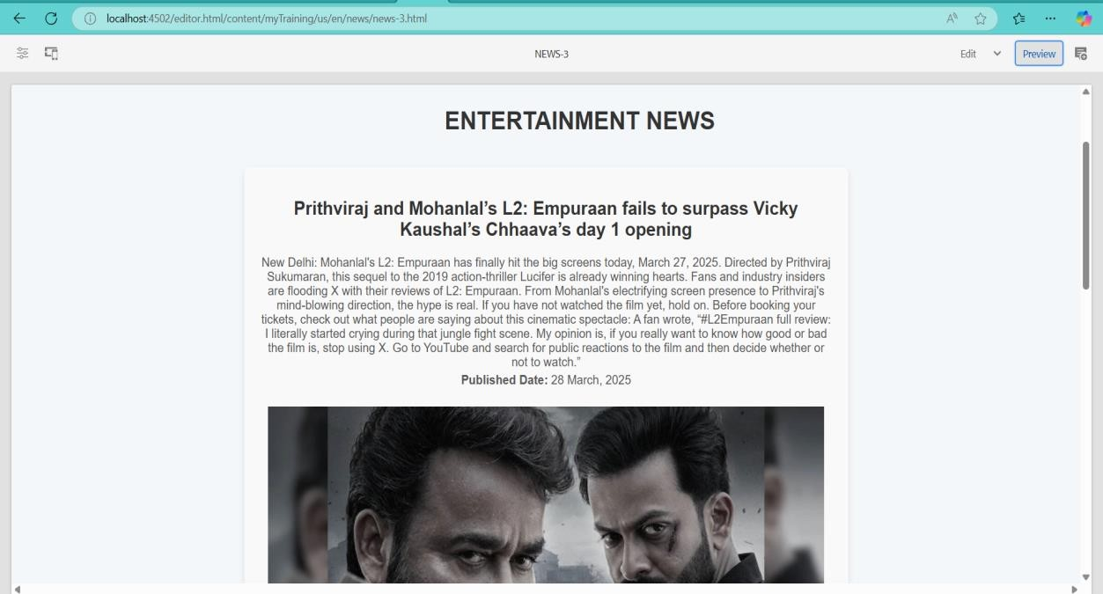

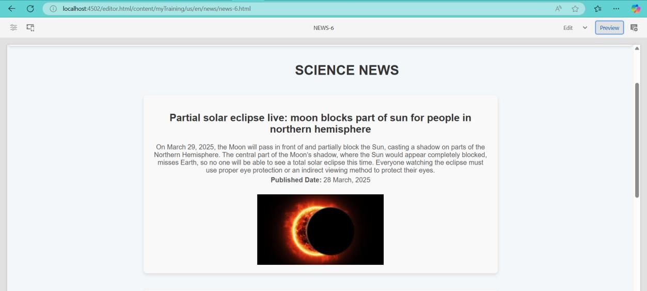

## About Me Page Implementation

* Used a **Journalist Component** to provide information about the journalist.

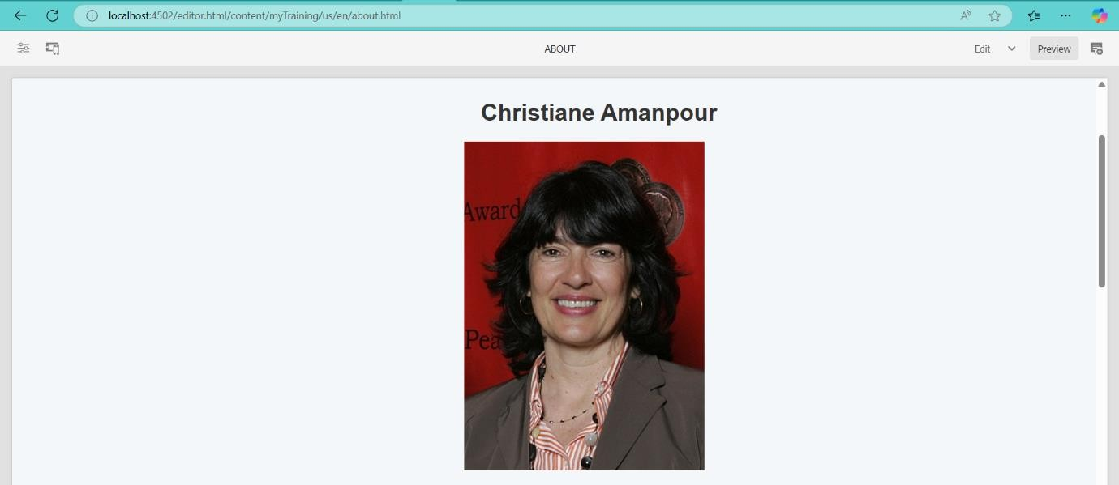

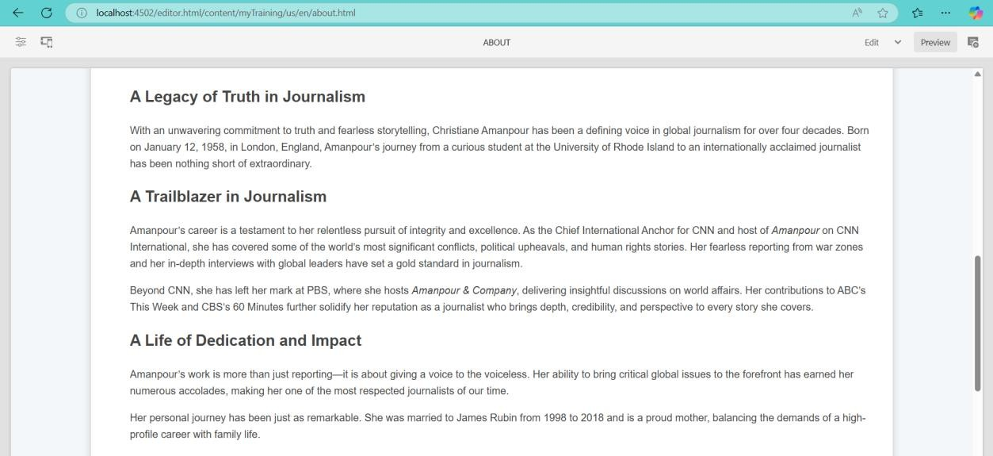

## Contact Me Page Implementation

* Used Teaser **Component** to:
  + Display contact details
  + Provide social media profile links for users to follow the journalist

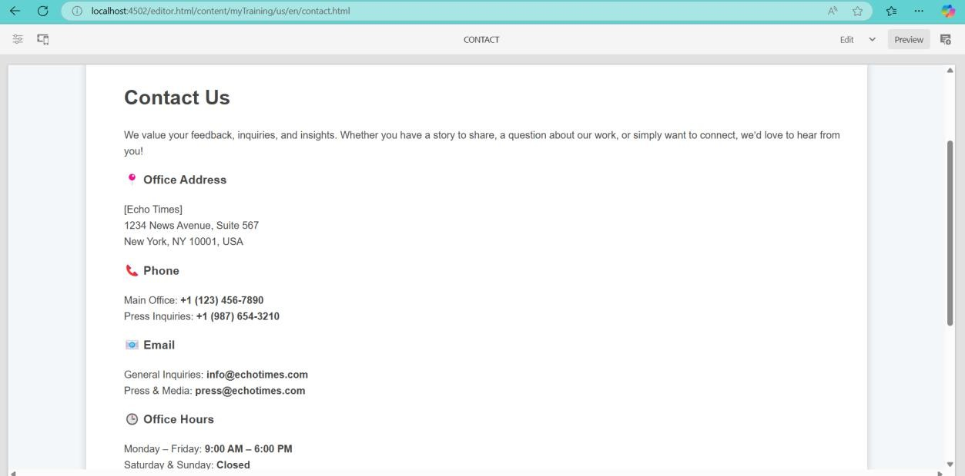

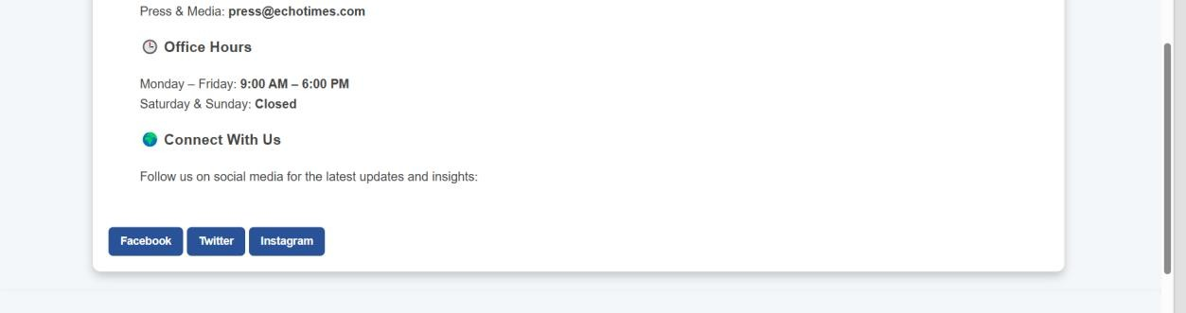

## Template-Level Implementation

* **Header and Footer** were added at the **template level** to ensure consistency across all pages.
* **Homepage** used the **OOTB Content Page Template**.
* **News Pages** used the **News Page Template** provided.

